**Introduction to HTML**

**What is the HTML**

HTML stands for **H**yper**T**ext **M**arkup **L**anguage.

* A **markup language** defines the structure and presentation of raw text.
* A **HyperText** is text displayed on a computer or device that provides access to other text through links (hyperlinks).

**HTML** is a markup language used to create documents on the web. It describes the structure and layout of a web page.

**History of HTML**

**HTML** was originally developed by Tim Berners-Lee while at CERN. While working at CERN, he became frustrated at having to log on to different computers to find different information and thought that there must be a better way. He figured that there must be a way to hop from one set of information to another that's on different computers. This concept of a hypertext system (connected with the networking technology and protocols needed to pass information between computers) would go on to form the basis for the fundamental language of the world wide web. HTML is a very evolving markup language and has gone through several changes since its inception.

| **Version** | **Year** |
| --- | --- |
| HTML | 1991 |
| HTML 2.0 | 1995 |
| HTML 3.2 | 1997 |
| HTML 4.01 | 1999 |
| XHTML | 2000 |
| HTML5 | 2014 |

Formun Üstü

HTML Page Structure

* The <head> element contains metadata about the page. HTML metadata is data about the HTML document and metadata is not displayed. Metadata typically defines the document title, character set, styles, scripts, and other meta information.
* The <body> element indicates what should appear in the main browser window.

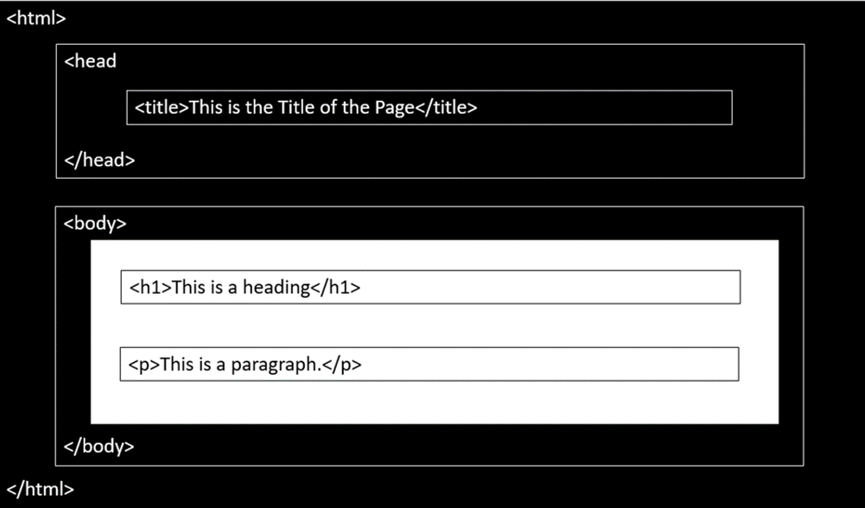

**A Simple HTML Document**

<!DOCTYPE html>

<html>

<head>

<title>Page Title</title>

</head>

<body>

<h1>This is a Heading</h1>

<p>This is a paragraph.</p>

</body>

</html>

Output:

**This is a Heading**

**This is a paragraph.**

**Explanation of HTML Document:**

* The <!DOCTYPE html> declaration defines this document to be HTML5.
* The <html> element is the root element of an HTML page.
* The <head> element contains meta information about the document.
* The <title> element specifies a title for the document.
* The <body> element contains the visible page content.
* The <h1> element defines a large heading.
* The <p> element defines a paragraph.

HTML Elements

You can find all elements used in HTML by following this [link.](https://www.w3schools.com/tags/default.asp)

HTML is composed of elements. HTML uses these elements to describe the structure of pages. A tag and the content between it is called an **HTML element**. Elements are usually made up of two tags: An **opening tag** and a **closing tag**. The opening tag is also called the starting tag, and the closing tag is called the end tag. Each HTML element tells the browser something about the information that is between its opening and closing tags.

You can find all elements used in HTML by following this [link.](https://www.w3schools.com/tags/default.asp)

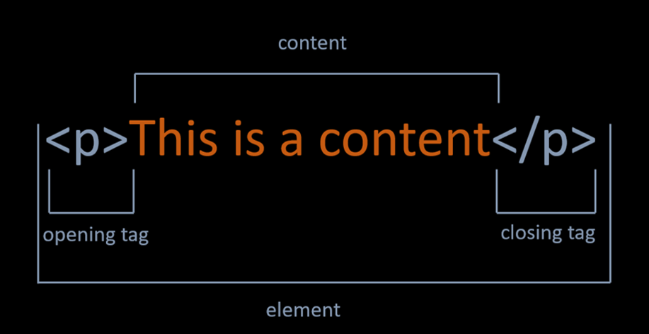

### Nested HTML Elements

HTML documents consist of nested HTML elements. HTML elements can contain elements (elements can be nested). All HTML documents composed of nested HTML elements.

<!DOCTYPE html>

<html>

<body>

<h1>This is a Heading</h1>

<p>This is a paragraph.</p>

</body>

</html>

# This is a Heading

This is a paragraph.

* HTML Document above contains four HTML elements.
* The HTML element includes the body element.
* The body element includes the h1 and p elements.

Empty HTML Elements

* If a HTML element does not have any content, it is called empty element.
* Empty HTML elements do not have a closing tag.
* For example, <br> and <img> elements are empty elements.
* You will learn more about elements in this course.

HTML Tags

* **HTML tags** are element names surrounded by angle brackets. The element name indicates the tag's purpose. For example, p stands for paragraph.
* The opening tag denotes the start of a piece of content. The opening tag is composed of the left-angle bracket, element name, and right-angle bracket.

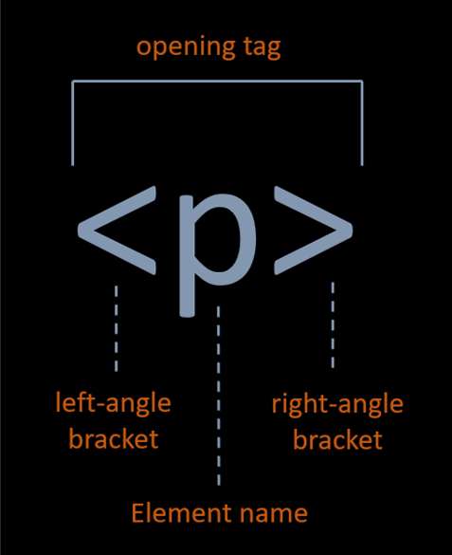

* the closing tag denotes the end of an HTML element. The closing tag is composed of the left-angle bracket, forward slash, element name, and right-angle bracket.

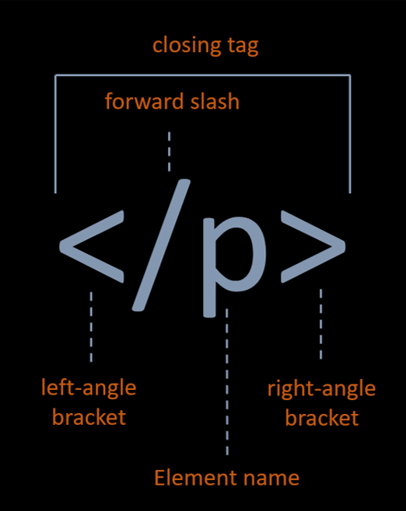

HTML Div Tag

A <div> section in a document that is styled with CSS:  
  
The <div> tag defines a division or a section in an HTML document.  
  
The <div> tag is used as a container for HTML elements - which is then styled with CSS or manipulated with JavaScript.  
  
The <div> tag is easily styled by using the class or id attribute.  
  
Any sort of content can be put inside the <div> tag!  
  
Note: By default, browsers always place a line break before and after the <div> element.

HTML Attributes

Attributes provide additional information about the contents of an element. Attributes are always specified in the opening tag and are made up of two parts: a name and a value, separated by an equals sign. For example, The style attribute is used to specify the styling of an element, like color, font, size etc.

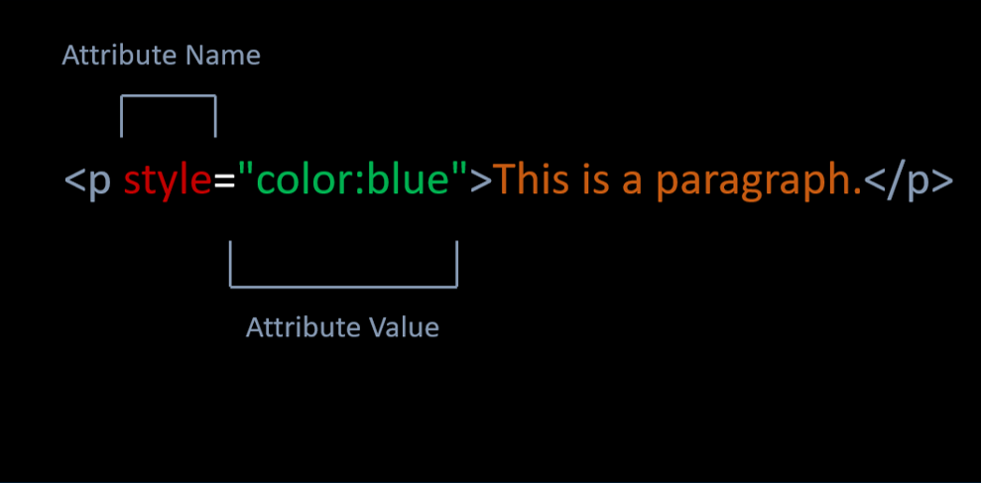

**HTML Text**

**HTML Headings**

Headings are used to describe content, like the title of an article. HTML has six "levels" of headings, which are graded according to importance. Headings are defined with the **<h1> to <h6> tags.** <h1> defines the most important heading. <h6> defines the least important heading.

<!</html>

Output:

# The most important heading

## This is heading 2

### This is heading 3

#### This is heading 4

##### **This is heading 5**

###### **The least important heading**

**HTML Paragraphs**

<!DOCTYPE html>

<html>

<body>

<p>This is first paragraph.</p>

<p>This is second paragraph.</p>

</body>

</html>

Output:

This is first paragraph.

This is second paragraph.

**Horizontal Lines**

* **The <hr> tag creates a horizontal line.**
* **The <hr> tag is displayed as a horizontal rule.**
* **The <hr> tag is used to separate content on a HTML page.**
* **<!DOCTYPE html>**
* **<html>**
* **<body>**
* **<h1>This is heading</h1>**
* **<p>Horizantal Line is below. </p>**
* **<hr>**
* **<p>Horizantal Line is above. </p>**
* **</body>**
* **</html>**
* **Output:**
* **This is heading**
* **Horizantal Line is below.**
* **Horizantal Line is above.**

**HTML Line Breaks**

* The HTML <br> tag stands for a line break.
* The <br> tag is used to add a single line break.
* The <br> tag has no end tag.
* <!DOCTYPE html>
* <html>
* <body>
* <p>This is a paragraph </p>
* <p>This is <br> a new line.</p>
* </body>
* </html>

Output:

This is a paragraph

This is  
a new line.

**HTML Comments**

* Comments can add the text between these characters.

<!-- This is a comment-->

* The browser does not display comments, but with comments, we can place warnings, descriptions and other notes.
* Comments are also imported for debugging HTML. We can use comments for searching errors.

### HTML < b > Element

The <b> element is used to define bold text.

<!DOCTYPE html>

<html>

<body>

<p>This is a <b>bold</b> text</p>

</body>

</html>

Output:

This is a **bold** text

HTML < strong > Element

* The <strong> element is used to define strong text.
* The <strong> element uses for the semantic(anlamsal) important texts.
* <!DOCTYPE html>
* <html>
* <body>
* <p>This is a <strong>strong</strong> text</p>
* </body>
* </html>

Output:

This is a **strong** text

### HTML < i > Element

The <i> element is used to define italic text.

<!DOCTYPE html>

<html>

<body>

<p>This is an <i>italic</i> text</p>

</body>

</html>

Output:

This is an *italic* text

### HTML < em > Element

* The <em> element is used to define emphasized text.
* <em> means that the text is "important".

<!DOCTYPE html>

<html>

<body>

<p>This is an <em>emphasized</em> text</p>

</body>

</html>

Output:

This is an emphasized text

The Difference Between Bold and Strong, Emphasized and Italics.

* <strong> and <b> tags make text bold. They're identical when it comes to presentation.
* <strong> represents a span of text with strong importance. There is an important semantic meaning here. They may look the same to humans. But, when a search engine spiders and analyzes a page, text in <strong> tags is considered important. Text in <b> tags is not.
* Just like <strong> and <b>, <em> and <i> are identical in terms of presentation. They both **make text italic**. There is no semantic meaning for <i> tag. But, <em> tag represents a span of text with emphatic stress like <strong> tag.

### HTML < small> Element

The <small> element is used to define smaller text.

<!DOCTYPE html>

<html>

<body>

<p>This is a <small>smaller</small> text</p>

</body>

</html>

Output:

This is an smaller text

### HTML < sup > Element

The <sup> element is used to define superscript characters such as the suffixes of dates.

<!DOCTYPE html>

<html>

<body>

<p>Today is 15<sup>th</sup> of february.</p>

</body>

</html>

Output:

Today is 15th of february.

### HTML < sub > Element

The <sub> element is used to define subscripted text.

<!DOCTYPE html>

<html>

<body>

<p>This is a <sub>subscripted</sub> text</p>

</body>

</html>

Output:

This is a subscripted text

### HTML < mark > Element

The <mark> element is used to define marked text.

<!DOCTYPE html>

<html>

<body>

<p>This is a <mark>marked</mark> text</p>

</body>

</html>

Output:

This is a marked text

### HTML < ins > Element

The <ins> element is used to define inserted text.

<!DOCTYPE html>

<html>

<body>

<p>This is an <ins>inserted</ins> text</p>

</body>

</html>

Output:

This is an inserted text

### HTML < del > Element

The <del> element is used to define deleted text.

<!DOCTYPE html>

<html>

<body>

<p>This is a <del>deleted</del> text</p>

</body>

</html>

Output:

This is a  text

### Summary of HTML Formatting Elements

| **Tag** | **Description** |
| --- | --- |
| < b > | Bold text |
| < i > | Italic text |
| < strong > | Strong text |
| < em > | Emphasized text |
| < small > | Smaller text |
| < sup > | Superscripted text |
| < sub > | Subscripted text |
| < mark > | Marked text |
| < ins > | Inserted text |
| < del > | Deleted text |

<!DOCTYPE html>

<html>

<body>

<p>This is a <b>bold</b> text</p>

<p>This is a <strong>strong</strong> text</p>

<p>This is an <i>italic</i> text</p>

<p>This is an <em>emphasized</em> text</p>

<p>This is a <small>small</small> text</p>

<p>Today is 15<sup>th</sup> of february.</p>

<p>This is a <sub>subscripted</sub> text</p>

<p>This is a <mark>marked</mark> text</p>

<p>This is a <ins>inserted</ins> text</p>

<p>This is a <del>deleted</del> text</p>

</body>

</html>

Output:

This is a **bold** text

This is a **strong** text

This is an *italic* text

This is an emphasized text

This is an smaller text

Today is 15th of february.

This is a subscripted text

This is a marked text

This is an inserted text

This is a  text

## HTML Formatting Elements )

### Ordered List Elements

* The <ol> element is used to create ordered lists with a sequential order.
* Each list item is defined by the <li> tag.

<!DOCTYPE html>

<html>

<body>

<h1>Ordered HTML List</h1>

<ol>

<li>Chevrolet</li>

<li>Chrysler</li>

<li>Dodge</li>

</ol>

</body>

</html>

Output:

# Ordered HTML List

1. Chevrolet
2. Chrysler
3. Dodge

### Unordered List Elements

* The <ul>element is used to create unordered lists with no particular order.

<!DOCTYPE html>

<html>

<body>

<h1>Unordered HTML List</h1>

<ul>

<li>Apple</li>

<li>Microsoft</li>

<li>Intel</li>

</ul>

</body>

</html>

Output:

# Unordered HTML List

* Apple
* Microsoft
* Intel

HTML Tables

Basics of Table

* In order to create a table in HTML, we use <table> tag.
* The <tr> tag is used to define each table row.
* The <th> tag defines a table header.
* A table cell is defined with the <td> tag.
* Here is an example of a simple table with four rows and two columns.

<!DOCTYPE html>

<html>

<body>

<table>

<tr>

<th>Day</th>

<th>Lesson</th>

</tr>

<tr>

<td>Monday</td>

<td>Java</td>

</tr>

<tr>

<td>Tuesday</td>

<td>HTML</td>

</tr>

<tr>

<td>Wednesday</td>

<td>CSS</td>

</tr>

</table>

</body>

</html>

Output:

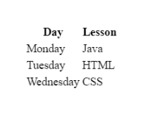

### Table Border

* We can add border to table with **border** attribute in table tag like example below.  
  <table border="number">

**⚠️Avoid:**

* The border attribute is not supported in HTML5. Use CSS instead.

<!DOCTYPE html>

<html>

<body>

<h1>Course Program</h1>

<table border="1">

<tr>

<th>Day</th>

<th>Lesson</th>

</tr>

<tr>

<td>Monday</td>

<td>Java</td>

</tr>

<tr>

<td>Tuesday</td>

<td>HTML</td>

</tr>

<tr>

<td>Wednesday</td>

<td>CSS</td>

</tr>

</table>

</body>

</html>

Output:

# Course Program

|  |  |
| --- | --- |
| **Day** | **Lesson** |
| Monday | Java |
| Tuesday | HTML |
| Wednesday | CSS |

### Colspan Attribute

* We can span two or more columns by using the colspan attribute like example below.  
  < td colspan="2" >Java< /td >

<!DOCTYPE html>

<html>

<body>

<h1>Course Program</h1>

<table border="1">

<tr>

<th>Day</th>

<th>Lesson-1</th>

<th>Lesson-2</th>

</tr>

<tr>

<td>Monday</td>

<td colspan="2">Java</td>

</tr>

<tr>

<td>Tuesday</td>

<td>Maven</td>

<td>Gradle</td>

</tr>

<tr>

<td>Wednesday</td>

<td>HTML</td>

<td>CSS</td>

</tr>

</table>

</body>

</html>

Output:

# Course Program

|  |  |  |
| --- | --- | --- |
| **Day** | **Lesson-1** | **Lesson-2** |
| Monday | Java | |
| Tuesday | Maven | Gradle |
| Wednesday | HTML | CSS |

### Rowspan Attribute

* We can span two or more rows by using the rowspan attribute like example below.  
  < td rowspan="2" >Java< /td >

<!DOCTYPE html>

<html>

<body>

<h1>Course Program</h1>

<table border="1">

<tr>

<th>Day</th>

<th>Lesson-1</th>

<th>Lesson-2</th>

</tr>

<tr>

<td>Monday</td>

<td>Java</td>

<td>Git</td>

</tr>

<tr>

<td rowspan="2">Tuesday</td>

<td>Maven</td>

<td>Gradle</td>

</tr>

<tr>

<td>HTML</td>

<td>CSS</td>

</tr>

</table>

</body>

</html>

Output:

# Course Program

|  |  |  |
| --- | --- | --- |
| **Day** | **Lesson-1** | **Lesson-2** |
| Monday | Java | Git |
| Tuesday | Maven | Gradle |
| HTML | CSS |

### Align Attribute

* To change table or cell position, we can use the align attribute inside <table> tag or <td> tag.  
  <td align="center">java</td >

<!DOCTYPE html>

<html>

<body>

<h1>Course Program</h1>

<table border="1">

<tr>

<th>Day</th>

<th>Lesson-1</th>

<th>Lesson-2</th>

</tr>

<tr>

<td>Monday</td>

<td align="center" colspan="2" >Java</td>

</tr>

<tr>

<td>Tuesday</td>

<td>Maven</td>

<td>Gradle</td>

</tr>

<tr>

<td>Wednesday</td>

<td>HTML</td>

<td>CSS</td>

</tr>

</table>

</body>

</html>

Output:

# Course Program

|  |  |  |
| --- | --- | --- |
| **Day** | **Lesson-1** | **Lesson-2** |
| Monday | Java | |
| Tuesday | Maven | Gradle |
| Wednesday | HTML | CSS |

**HTML Images**

The < img > Tag

* We can improve the design of a web page by adding [images](https://lms.clarusway.com/mod/lesson/view.php?id=12121).
* The <img> tag is used to define an image.
* The <img> tag is empty. It means that it does not have a closing tag.
* The **src** attribute allows us to specify the web address (URL) of the image and it is mandatory.

<!DOCTYPE html>

<html>

<body>

<h1>HTML Image</h1>

<img src="https://lms.clarusway.com/theme/image.php/boost/theme_boost/1581703952/Clarusway-LOGOTYPE">

</body>

</html>

Output:

HTML Image

https://clarusway.com/wp-content/uploads/2019/12/cw_sonk%C3%BC%C3%A7%C3%BCk2.png

The alt attribute

* The **alt** attribute is used to provide an alternate text for an image in case the image fails to load on a web page or it is not supported by the browser, etc.
* Moreover, Visually impaired users browse the web via screen reading software. the screen reading software can read the text inside an alt attribute for impaired users.
* We should add alt attribute to the image tag just like the src attribute.

<!DOCTYPE html>

<html>

<body>

<h1>HTML Image</h1>

<img src="https://clarusway.comt/uploads/2019/11/ClaruswayLOGO_png100_326.png" alt="Clarusway">

</body>

</html>

Output:

HTML Image

Clarusway

The width and height attributes

* The width and height attributes are used to resize [images](https://lms.clarusway.com/mod/lesson/view.php?id=12121).

<!DOCTYPE html>

<html>

<body>

<h1>HTML Image</h1>

<h2>Clarusway</h2>

<img src="https://clarusway.com/wp-content/uploads/2019/11/ClaruswayLOGO_png100_326.png" alt="Clarusway" width="100%" height="auto">

</body>

</html>

Output:

HTML Image

Clarusway

Clarusway

Formun Üstü

Previous

Formun Altı

Formun Üstü

Next

Formun Altı

The border attribute

* By default, an image has no borders.
* To add a border around the image, we can use border attribute.

<!DOCTYPE html>

<html>

<body>

<h1>HTML Image</h1>

<img src="https://clarusway.com/wp-content/uploads/2019/12/cw_sonk%C3%BC%C3%A7%C3%BCk2.png" alt="Clarusway" border="2px">

</body>

</html>



Formun Altı

Formun Altı